Short
North Coast Health Connect: Helping you get the right care in the right place at the right time.
North Coast Health Connect is a free new service providing health support and advice from registered nurses 24 hours a day, 7 days a week, including public holidays. Residents and visitors to the North Coast can speak or web chat live with a nurse, who will discuss your symptoms and provide advice on what to do next.
Visit https://northcoasthealthconnect.org.au/ for more info and save as a contact for when you need it by visiting https://qrco.de/bdkiJm or by scanning the QR code below.
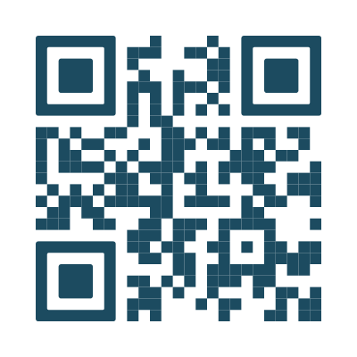

Long
North Coast Health Connect: Helping you get the right care in the right place at the right time.
North Coast Health Connect is a free new service providing health support and advice from registered nurses 24 hours a day, 7 days a week, including public holidays. Residents and visitors to the North Coast can speak or web chat live with a nurse, who will ask some questions to understand what’s troubling you and then provide advice on what your next step should be.
Our nurses may provide self-care advice to help you to manage your health from home, or the nurse may recommend a GP appointment or a consultation with a pharmacist. Our nurses can book an appointment for you directly with a local participating general practice or pharmacy or, if appropriate, can transfer you to a GP telehealth service. If the nurse believes you need to attend an emergency department or see a different health service, they will also let you know.
Visit https://northcoasthealthconnect.org.au/ for more info and save as a contact for when you need it by visiting https://qrco.de/bdkiJm or by scanning the QR code below.

